


Ministry of Tourism and Environment

Water and Sewerage Emergency Plan Template
April 2025
Table 1: Details of WSEP updates overtime
Version | Date | Changes | Author(s)
1 | [Date] | Initial draft | [Your Name]

Table of Contents
List of Figures 4
List of Tables 4
1 Company Profile 5
2 Objectives 5
3 Scope 5
4 Water and Sewerage Emergency Plan 6
5 Stage 1: Preparation 6
5.1 WSEP Team 7
5.2 System Description 9
5.2.1 System Mapping – Water Service 9
5.2.2 System Mapping – Sewerage Service 13
5.3 Gap Analysis 16
6 Stage 2: Prevention and Mitigation 17
6.1 Hazard Identification, Risk Assessment and Control Measures 17
6.1.1 Hazard Identification 17
6.1.2 Risk Assessment 17
6.1.3 Risk Prioritization 17
6.1.4 Control Measures 18
6.1.5 Residual Risk and Risk Acceptance 18
7 Stage 3: Preparedness 20
7.1 Emergency Preparedness 20
7.1.1 Resource Management 20
7.1.2 Training, Drills and Exercises 20
7.1.3 Communication and Coordination 21
7.1.4 Continuous Improvement 22
7.2 Annual Action Plan for WSEP Activities 22
8 Stage 4: Response 23
8.1 Emergency Classification 23
8.2 Emergency Operation Plans 24
8.3 Crisis Communication Plan 25
8.3.1 Communication Flow Chart and Protocols 25
8.3.2 Public Notification 26
8.4 Business Continuity Plan 27
Stage 5: Recovery 28
8.5 Recovery Procedures 28
8.6 Post-Emergency Reporting 28
8.7 Response Evaluation 29

List of Figures
Figure 1: Components of WSEP 6
Figure 2: WSEP response coordination flow diagram 7
Figure 3: Crisis Communication Plan 25

List of Tables
Table 1: Details of WSEP updates overtime 2
Table 2: Utility-WSEP Coordination Team (Regional/National Level) members 8
Table 3: Utility-WSEP Coordination Team (Island Level) members 8
Table 4: WSEP Steering committee members 8
Table 5: Water treatment plant specifications 9
Table 6: Raw/feed water properties (URA, 2021) 9
Table 7: Baseline flowrate and pressure of Water Treatment stages (Edit as per actual process) 10
Table 8: Baseline performance of Water Treatment stages 10
Table 9: Permeate Baseline Quality (URA, 2022) 11
Table 10: Critical components in the treatment plant and their specifications (Edit as per actual process) 12
Table 11: Storage Tank Details 12
Table 12: Daily Water Distribution and Demand Data 12
Table 13: Details of consumers in the water network 13
Table 14: Sewerage System specifications 13
Table 15: Wastewater discharge properties (URA, 2023) 13
Table 16: Baseline performance of Sewerage System (Calculated from Table 7 values) 14
Table 17: Wastewater treatment process 14
Table 18: Critical components in the sewerage system and their specifications (Edit as per actual process) 15
Table 19: Hazard Identification 17
Table 20: Risk Assessment 17
Table 21: HIRA Register 19
Table 22: Emergency Preparedness and Response Trainings 20
Table 23: Annual Action Plan for WSEP Activities 22
Table 24: Emergency Level Identification System 23
Table 25: Incident Report 28

Company Profile
Description: A brief overview of the utility's operations, including its services, customers, and geographic coverage.
Organizational Structure: The hierarchical structure of the utility, outlining the roles and responsibilities of different departments and personnel.
Geographical Location: The specific areas served by the utility, including the number of islands and the population served. Details of the area being focused in this Water and Sewerage Emergency Plan (WSEP).

Objectives
The primary objectives of this WSEP are to:
- Operational Continuity: Maintaining uninterrupted water and sewage services during emergencies.
- Impact Mitigation: Reducing the financial, environmental, and infrastructural consequences of emergencies.
- Effective Communication: Establishing clear internal and external communication channels.
- Swift Restoration: Implementing rapid service recovery strategies to minimize disruptions.
- Regulatory Compliance: Adhering to all relevant emergency preparedness and response standards.

Scope
This WSEP aims to address the potential impacts of various hazards on the water and sewerage system, including:
- Disruption of water and sewerage services: Interruptions in water supply or sewage service.
- Contamination of water and sewage: Introduction of harmful substances into the water or sewage systems.
- Damage to infrastructure: Physical damage to water and sewerage facilities.
The WSEP covers a wide range of emergencies, including:
- Natural disasters: Cyclones, floods, tsunamis, earthquakes, droughts, and other climate-related events.
- Infrastructure failures: Equipment failures, power outages, water shortages, and communication disruptions.
- Human-made hazards: Chemical spills, fires, explosions, vandalism, terrorism, and other intentional or accidental acts.
- Biological hazards: Waterborne diseases, infectious diseases, and biological contamination.

Water and Sewerage Emergency Plan
This is a document that outlines strategies, resources, plans, and procedures for responding to emergencies that threaten the water and sewerage system. This plan encompasses five key stages (Figure 1): Prevention, Mitigation, Preparedness, Response and Recovery.

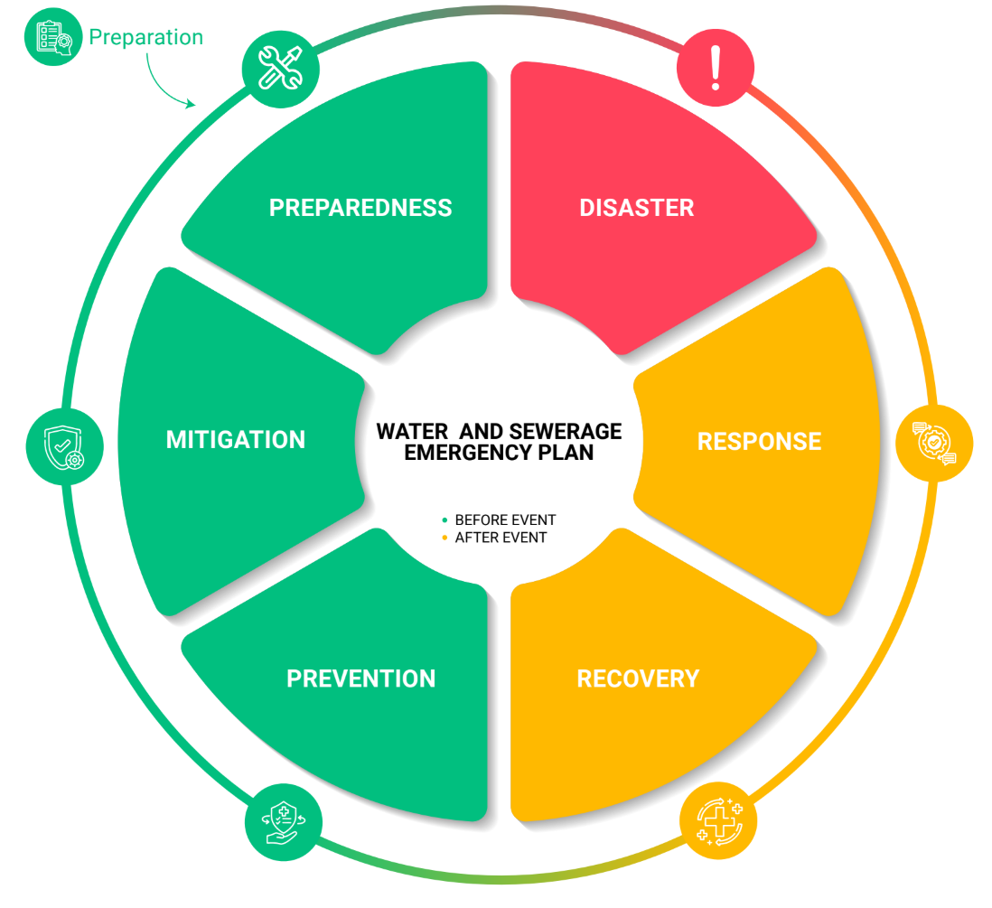
Figure 1: Components of WSEP

Stage 1: Preparation
The objective of this step is to:
- Obtain and allocate resources for the development and implementation of WSEP.
- Form a multi-disciplinary planning team for emergency preparedness and response.
- Involve key stakeholders, such as government agencies, community representatives, and NGOs, in the WSEP development process

WSEP Team
The response coordination teams will consist of three main components defined at a regional/national level and the island level.
- Utility-WSEP Coordination Team (Regional/National Level): This team will be responsible for providing strategic direction, allocating resources, and ensuring organizational commitment.
- Utility-WSEP Team (Island Level): This team will be responsible for implementing the WSEP at the island level.
- WSEP Steering Committee: This committee is a high-level body responsible to oversee the development and implementation of the WSEP.
Utility Emergency Response Coordination
Regional / National Level | Utility – WSEP Coordination Team  - Senior management  - Procurement and logistic staff  - Engineering experts  - Health and safety professionals  - Communication specialists  - Legal and compliance officers
Island  Level | Utility – WSEP Team  - Incident controller  - Safety Officer  - Operational staff  - Technicians x 4  - Procurement staff x 1  - Logistics staff x 1  - Communication staff x1 |  | - WSEP Steering Committee (equivalent to Disaster Management Committee)  - Utility (Lead agency)  - Island Council  - Health Sector Representative  - Households  - *Police  - *MNDF  - *NDMA,  - *MoT  - *HPA  - *EPA  - *MMS  - *PWS  - *MRC  - *Media
Figure 2: WSEP response coordination flow diagram

Table 2: Utility-WSEP Coordination Team (Regional/National Level) members
Focal Point Name | Designation | Contact Information | Role in WSEP (Examples)
[Name] | [Designation] | [Contact no.] | Senior Management
[Name] | [Designation] | [Contact no.] | Engineering experts
[Name] | [Designation] | [Contact no.] | Health and Safety Professional
[Name] | [Designation] | [Contact no.] | Communication Specialist
[Name] | [Designation] | [Contact no.] | Legal and Compliance Officer
[Name] | [Designation] | [Contact no.] | Procurement Staff
[Name] | [Designation] | [Contact no.] | Logistic Staff
Table 3: Utility-WSEP Coordination Team (Island Level) members
Focal Point Name | Designation | Contact Information | Role in WSEP (Examples)
[Name] | [Designation] | [Contact no.] | Incident Controller
[Name] | [Designation] | [Contact no.] | Safety Officer
[Name] | [Designation] | [Contact no.] | Operational Staff
[Name] | [Designation] | [Contact no.] | Technician
[Name] | [Designation] | [Contact no.] | Procurement Staff
[Name] | [Designation] | [Contact no.] | Logistic Staff
[Name] | [Designation] | [Contact no.] | Public Information Officer
Table 4: WSEP Steering committee members
Stakeholder / Agency  (Examples) | Focal Point Name / Designation | Contact Information | Role in WSEP
Utility | [Name] / [Designation] | [Contact no.] | [Lead agency]
Island Council | [Name] / [Designation] | [Contact no.] | [Supporting agency]
Households | [Name] / [Designation] | [Contact no.] | [Users]
Maldives Police Service | [Name] / [Designation] | [Contact no.] | [Supporting / Law enforcement agency]
Health Center | [Name] / [Designation] | [Contact no.] | [Supporting agency]
Fire and Rescue Service | [Name] / [Designation] | [Contact no.] | [Supporting / Response agency]
Maldives National Defense Force | [Name] / [Designation] | [Contact no.] | [Supporting / Response agency]
Maldives Red Crescent | [Name] / [Designation] | [Contact no.] | [Supporting / Response agency]
Local NGO | [Name] / [Designation] | [Contact no.] | [Supporting agency]
Ministry of Tourism and Environment | [Name] / [Designation] | [Contact no.] | [Supporting agency]
*Include organization chart of Emergency Response Team

System Description
This step is an in-depth assessment which will inform subsequent risk assessment and mitigation strategies.
- System Mapping: Create a detailed representation of the water and sewerage infrastructure, including sources, treatment facilities, distribution networks, and disposal points.
- System Performance Evaluation: Collect quantitative baseline data on system performance, such as flow rates, water quality parameters, and treatment efficiency.
- Gap Analysis: Identify deficiencies in the system, such as inadequate capacity, outdated infrastructure, or insufficient emergency response procedures.

System Mapping – Water Service
The water treatment plant has the following specifications.
Table 5: Water treatment plant specifications
Description | Treatment Plant One | Treatment Plant Two
Date Established | [Date] | [Date]
Make / Model | [Brand/Model/Contractor] | [Brand/Model/Contractor]
Capacity (m³/day) | [Production in 20 hours] | [Production in 20 hours]
Feed tank (m³) | [m³ / NA] | [m³ / NA]
Pretreatment method | [Sand filter / Multimedia filter]  [Cartridge filter / Bag filter] | [Sand filter / Multimedia filter]  [Cartridge filter / Bag filter]
Number of RO Vessels | [Value] | [Value]
Number of RO Membranes | [Value] | [Value]
Disinfection Method | [UV / Chlorine / Ozone] | [UV / Chlorine / Ozone]
Distribution Method | [Overhead tanks / Booster pumps] | [Overhead tanks / Booster pumps]
Water source
The raw/feed water used for the water service has the following properties.
Number of sources: [Number of sources]
Table 6: Raw/feed water properties (URA, 2021)
Description | Source One | Source Two
Intake method | [Borehole / Seawater] | [Borehole / Seawater]
Depth of Source (m) | [Depth] | [Depth]
Diameter of borewell/intake (mm) | [Diameter] | [Diameter]
Date of drilling | [Date] | [Date]
GPS Coordinates | [Coordinates] | [Coordinates]
Water Quality – Physical parameters
Visual Appearance – color if any | [Observation] | [Observation]
Turbidity (NTU) | [Value] | [Value]
Temperature (°C) | [Value] | [Value]
pH | [Value] | [Value]
Water Quality – Chemical parameters
Total Dissolved Solids (mg / L) | [Value] | [Value]
E. Conductivity (μS / cm) | [Value] | [Value]
Calcium Hardness (mg / L) | [Value] | [Value]
Magnesium Hardness (mg / L) | [Value] | [Value]
Boron (mg / L) | [Value] | [Value]
Phosphate (mg / L) | [Value] | [Value]
Sulphate (mg / L) | [Value] | [Value]
Iron (mg / L) | [Value] | [Value]
Chloride (mg / L) | [Value] | [Value]
Fluoride (mg / L) | [Value] | [Value]
Nitrates (mg / L) | [Value] | [Value]
Ammonia (mg / L) | [Value] | [Value]
Sulfate (mg / L) | [Value] | [Value]
Lead (mg / L) | [Value] | [Value]
Water Treatment
The following treatment processes are carried out in the water treatment with the provided baseline pressure and flow measurements.
Table 7: Baseline flowrate and pressure of Water Treatment stages (Edit as per actual process)
Stage  (Measured/Read from flow meters and pressure gauges in the plant) | Treatment Plant One |  | Treatment Plant Two
 | Flow (m³/hr) | Pressure (Bar) | Flow (m³/hr) | Pressure (Bar)
Feed | [Value] | [Value] | [Value] | [Value]
Sand Filter / Multi-media filter inlet | [Value] | [Value] | [Value] | [Value]
Sand Filter / Multi-media filter outlet | [Value] | [Value] | [Value] | [Value]
Bag Filter / Cartridge filter inlet | [Value] | [Value] | [Value] | [Value]
Bag Filter / Cartridge filter outlet | [Value] | [Value] | [Value] | [Value]
High pressure pump inlet | [Value] | [Value] | [Value] | [Value]
Permeate | [Value] | [Value] | [Value] | [Value]
Reject | [Value] | [Value] | [Value] | [Value]
Chemical dosing (Chlorine / Acid / Base / Antiscalant) | [Value] | [Value] | [Value] | [Value]
Other Indicators (Read from Panel)
Grid Energy Consumption (kWh) | [Value] |  | [Value]
Solar Energy Consumption (kWh) | [Value] |  | [Value]
Running hours (hr) | [Value] |  | [Value]

Table 8: Baseline performance of Water Treatment stages
Indicator | Treatment Plant One | Treatment Plant Two
Recovery (%) | [Flow rate of permeate / Flow rate of feed water] | [Flow rate of permeate / Flow rate of feed water]
Salt Rejection (%) | [Conductivity of feed water / Conductivity of permeate] | [Conductivity of feed water / Conductivity of permeate]
Sand Filter / Multi-media Pressure Drop (bar) | [Sand Filter / Multi-media filter outlet – inlet] | [Sand Filter / Multi-media filter outlet – inlet]
Bag Filter / Cartridge filter Pressure Drop (bar) | [Bag Filter / Cartridge filter outlet – inlet] | [Bag Filter / Cartridge filter outlet – inlet]
Specific Energy Consumption – SEC (kWh/m³) | [Energy consumption (kWh/hr) / Permeate flow rate (m³/hr)] | [Energy consumption (kWh/hr) / Permeate flow rate (m³/hr)]
Baseline water quality of permeate should be measured and recorded in Table 9.
Table 9: Permeate Baseline Quality (URA, 2022)
Description | Treatment Plant One | Treatment Plant Two | URA Standard
Water Quality – Physical parameters
Visual Appearance – color if any | [Observation] | [Observation] | Clear
Turbidity (NTU) | [Value] | [Value] | < 1 NTU
Temperature (°C) | [Value] | [Value] | NA
pH | [Value] | [Value] | 6.5 – 8.5
Water Quality – Biological parameters
Total Coliform (CFU / 100ml) | [Value] | [Value] | 0
Fecal Coliform (CFU / 100ml) | [Value] | [Value] | 0
E.Coli (CFU / 100ml) | [Value] | [Value] | 0
Total Viable Count at 22°C  (CFU / 100ml) | [Value] | [Value] | 100
Total Viable Count at 37°C  (CFU / 100ml) | [Value] | [Value] | 20
Enterococci (CFU / 100ml) | [Value] | [Value] | 0
Salmonella Typhi (CFU / 100ml) | [Value] | [Value] | 0
Shigella spp. (CFU / 100ml) | [Value] | [Value] | 0
Vibrio Cholerae (CFU / 100ml) | [Value] | [Value] | 0
Water Quality – Chemical parameters
Free Chlorine (mg/L) | [Value] | [Value] | 0.04 – 0.2
Total Dissolved Solids (mg / L) | [Value] | [Value] | <500
E. Conductivity (μS / cm) | [Value] | [Value] | <1000
Total Hardness (mg / L) | [Value] | [Value] | <75
Chlorides (mg / L) | [Value] | [Value] | <200
Nitrates (mg / L) | [Value] | [Value] | <50
Ammonia (mg / L) | [Value] | [Value] | <0.02 – 2.50
Iron (mg / L) | [Value] | [Value] | <0.3
Hydrogen Sulphide (mg / L) | [Value] | [Value] | 0.05
Suspended Solids (mg / L) | [Value] | [Value] | 5 – 750
Anionic detergents (mg / L) | [Value] | [Value] | 0.002 – 0.275
Arsenic (mg / L) | [Value] | [Value] | <0.01
Boron (mg / L) | [Value] | [Value] | <0.3
Bromine (mg / L) | [Value] | [Value] | 0.05 – 4.50
Cadmium (mg / L) | [Value] | [Value] | <0.003
Calcium Hardness (mg / L) | [Value] | [Value] | <60
Chromium (mg / L) | [Value] | [Value] | <0.05
Copper (mg / L) | [Value] | [Value] | <2
Cyanide (mg / L) | [Value] | [Value] | <0.07
Fluoride (mg / L) | [Value] | [Value] | <1.5
Lead (mg / L) | [Value] | [Value] | <0.01
Manganese (mg / L) | [Value] | [Value] | 0.1
Mercury (mg / L) | [Value] | [Value] | <0.001
Phenolic Compounds (mg / L) | [Value] | [Value] | 0.002 – 0.2
Phosphate (mg / L) | [Value] | [Value] | <5
Potassium (mg / L) | [Value] | [Value] | 0 – 50
Sodium (mg / L) | [Value] | [Value] | <200
Sulphate (mg / L) | [Value] | [Value] | <250
Total Petroleum hydrocarbon (mg / L) | [Value] | [Value] | 0
In addition to the above detail’s critical components of the treatment plant can be listed and tabulated for easy troubleshooting and replacement works in case of emergency. These details are provided in Table 10 below.
Table 10: Critical components in the treatment plant and their specifications (Edit as per actual process)
Component | Brand | Model | Size (kW) | Condition
Borehole Pump | [Brand] | [Model] | [kW] | [Good/Damaged]
Feed Pump | [Brand] | [Model] | [kW] | [Good/Damaged]
RO High Pressure Pump 1 | [Brand] | [Model] | [kW] | [Good/Damaged]
RO High Pressure Pump 2 | [Brand] | [Model] | [kW] | [Good/Damaged]
Energy Recovery Pump | [Brand] | [Model] | [kW] | [Good/Damaged]
Transfer Pump | [Brand] | [Model] | [kW] | [Good/Damaged]
Dosing Pump | [Brand] | [Model] | [kW] | [Good/Damaged]
CIP Pump | [Brand] | [Model] | [kW] | [Good/Damaged]
Washing Pump | [Brand] | [Model] | [kW] | [Good/Damaged]
Degasifier Blower | [Brand] | [Model] | [kW] | [Good/Damaged]
Distribution Pump | [Brand] | [Model] | [kW] | [Good/Damaged]
Outfall Pump | [Brand] | [Model] | [kW] | [Good/Damaged]

Water Distribution Network
Table 11: Storage Tank Details
Tank Details | Tank Capacity (m³) | Location | Type /  Brand | Date  Installed | Condition
Storage Tank 1 | [Value] | [Location] | [Type/Brand] | [Date] | [Condition]
Storage Tank 2 | [Value] | [Location] | [Type/Brand] | [Date] | [Condition]
Rainwater Storage Tank 1 | [Value] | [Location] | [Type/Brand] | [Date] | [Condition]
Rainwater Storage Tank 2 | [Value] | [Location] | [Type/Brand] | [Date] | [Condition]
Table 12: Daily Water Distribution and Demand Data
Parameter | Average Daily Value
Daily Water Production (m³/day) | [Value]
Daily Water Distribution (m³/day) | [Value]
Estimated Peak Demand (m³/hour) | [Value]
Non-Revenue Water (NRW) Volume (m³/day) | [Value]
Non-Revenue Water (NRW) % | [Value]
Average Distribution Pressure (Bar) | [Value]
Insert or Annex detailed drawings of water distribution network. This should include maps of the pipeline, zonal isolation valve locations, washout valve locations, location of storage tanks, pumps and booster stations. Pipe material, diameter, age, length, network map, pressure zones, hydrant locations should be included.
(These drawings are normally provided by contractors or developers of the system. In case they are unavailable, it is important to prepare them for emergency preparedness, troubleshooting, operation and maintenance)
Consumer Details
Identify type of water users based on residential, commercial, public industrial, and agricultural water users. To identify critical infrastructure like hospitals and other critical consumption points.
Table 13: Details of consumers in the water network
Consumer type | Number of connections | Network Zone
Residential | [Value] | [Zone]
Commercial | [Value] | [Zone]
Harbor | [Value] | [Zone]
Industrial | [Value] | [Zone]
Agriculture | [Value] | [Zone]
Public / Government
Schools | [Value] | [Zone]
Health Centers / Hospitals | [Value] | [Zone]
Offices | [Value] | [Zone]

System Mapping – Sewerage Service
The sewerage system has the following specifications. The sewerage system has [value] catchments.
Table 14: Sewerage System specifications
Description | Catchment One | Catchment Two
Date Established | [Date] | [Date]
Type | [Conventional Gravity / Vacuum / Smallbore] | [Conventional Gravity / Vacuum / Smallbore]
Number of Pump Stations | [Value] | [Value]
Number of Manholes | [Value] | [Value]
The sewerage waste has the following baseline characteristics based on water quality testing.
Number of sources: 2
Table 15: Wastewater discharge properties (URA, 2023)
Description | Raw wastewater | Treated wastewater  (if treatment is available)
Discharge Type | [Outfall / groundwater recharge / reuse]
Depth of Discharge (m) | [Depth]
Diameter of outfall (mm) | [Diameter]
Date of Installation | [Date]
Discharge condition | [Good/Damaged]
GPS Coordinates | [Coordinates]
Water Quality – Physical parameters
Visual Appearance – color if any | [Observation] | [Observation]
Turbidity (NTU) | [Value] | [Value]
Temperature | [Value] | [Value]
pH | [Value] | [Value]
Water Quality – Chemical parameters
Fecal coliforms (100 CFU/100ml) | [Value] | [Value]
E. coli 1 CFU/ 100 ml | [Value] | [Value]
Suspended Solids (mg / L) | [Value] | [Value]
Residual Chlorine (mg / L) | [Value] | [Value]
Nitrates as N (mg / L) | [Value] | [Value]
Free and saline Ammonia as N  (mg / L) | [Value] | [Value]
Ortho-phosphate as P (mg / L) | [Value] | [Value]
Surfactants (mg / L) | [Value] | [Value]
Total Dissolved Solids (mg / L) | [Value] | [Value]
E. Conductivity (μS / cm) | [Value] | [Value]
Soaps, oils and grease (food related) (mg / L) | [Value] | [Value]
Oil, grease and waxes (mg / L) | [Value] | [Value]
Chemical Oxygen Demand (mg / L) | [Value] | [Value]
Biological Oxygen Demand (mg / L) | [Value] | [Value]
Phenolic Compounds as Phenol (mg / L) | [Value] | [Value]
Sum of metals (mg / L) | [Value] | [Value]
Sewerage Collection System
Insert or Annex detailed drawings of sewerage collection system. This should include maps of the gravity and pressure mains, pump stations, manholes, cleanouts, location of treatment plants and discharge pump stations. (These drawings are normally provided by contractors or developers of the system. In case they are unavailable, it is important to prepare them for emergency preparedness, troubleshooting, operation and maintenance)
Table 16: Baseline performance of Sewerage System (Calculated from Table 7 values)
Indicator | Catchment One | Catchment Two
Grid Energy Consumption (kWh) | [Value] | [Value]
Solar Energy Consumption (kWh) | [Value] | [Value]
Running hours (hr) | [Value] | [Value]
Running counter(nos) | [Value] | [Value]
Pump Flowrate (m³/hr) | [Pump flowrate] | [Pump flowrate]
Average Wastewater generation (m³/hr) | [(Pump Flow Rate * Pump Running Hours) / 24 hours] | [(Pump Flow Rate * Pump Running Hours) / 24 hours]
Retention Volume (m³) | [Volume of network (pipes, manholes, catchpits) + Volume of pump stations] | [Volume of network (pipes, manholes, catchpits) + Volume of pump stations]
Retention time (hr) | [Retention volume / wastewater generation(m³/hr)] | [Retention volume / wastewater generation(m³/hr)]
Wastewater treatment facilities
The wastewater treatment process is described in the Table 17 below.
Table 17: Wastewater treatment process
Treatment Process | Treatment Plant 1 | Treatment Plant 2
Primary Treatment | [Describe process, e.g., screening, grit removal] | [Describe process]
Secondary Treatment | [Describe process, e.g., biological treatment] | [Describe process]
Tertiary Treatment | [Describe process, e.g., disinfection, nutrient removal] | [Describe process]
Capacity | [Flow rate in m³/day or other suitable unit] | [Flow rate]
Sludge Management | [Method, e.g., Sludge thickening, dewatering, disposal] | [Method]
Effluent Disposal | [Method, e.g., discharge to sea, groundwater recharge, reuse] | [Method]
Outfall Depth (m) | [Depth Value] | [Depth Value]
In addition to the above detail’s critical components of the treatment plant can be listed and tabulated for easy troubleshooting and replacement works in case of emergency. These details are provided in Table 18 below.
Table 18: Critical components in the sewerage system and their specifications (Edit as per actual process)
Component | Brand | Model | Size (kW) | Condition
Lifting Submersible Pump | [Brand] | [Model] | [kW] | [Good/Damaged]
Outfall Discharge Pump | [Brand] | [Model] | [kW] | [Good/Damaged]
Vacuum Pump | [Brand] | [Model] | [kW] | [Good/Damaged]
Transfer Pump | [Brand] | [Model] | [kW] | [Good/Damaged]
Sludge Pump | [Brand] | [Model] | [kW] | [Good/Damaged]

Gap Analysis
Identify the following in this section
- Capacity shortfalls: Assess if the system can handle peak demand, future growth, and emergencies.
- Infrastructure deterioration: Evaluate the condition of pipes, pumps, and treatment plants.
- Operational shortcomings: Analyze procedures, maintenance, and staffing.
- Regulatory compliance issues: Ensure adherence to relevant standards.
This section can include long term historical demand of water of the island. Comparisons with current demand and current production of water for water systems. Also comparison of running hours and running count overtime for sewerage systems and reports of overflows or sewer leaks to determine if there are any operational shortcomings in the sewer system operations.

Stage 2: Prevention and Mitigation

Hazard Identification, Risk Assessment and Control Measures
(This section focuses on identifying potential hazards, assessing associated risks, and evaluating existing control measures within the water and sewerage system. The goal is to prioritize high-risk areas and develop targeted mitigation and prevention strategies.)

Hazard Identification
(Identify and record the potential hazards in the water/sewerage system along with their exposure groups and routes. For each hazard, list down the potential impacts that maybe caused due to the hazard or hazardous event.)
Table 19: Hazard Identification
Hazard | Exposure Group | Exposure Route | Potential Impact

Risk Assessment
(For the above-mentioned hazards, use a risk assessment and evaluation tool to determine the risk posed by each hazard. You may use the method described in the Water and Sewerage Emergency Planning Guidebook. If another tool is utilized, describe the methodology including the assessment criteria in detail. Regardless of which methodology is followed, it is important to determine the likelihood and severity of each hazard, and determine a risk score/level based on the evaluation.)
Table 20: Risk Assessment
Hazard | Likelihood | Severity | Risk Value | Risk Level

Risk Prioritization
(Based on the risk levels determined from the risk assessment, highlight and rank the hazards that must be prioritized to ensure short-, medium- and long-term response strategies are planned and implemented to address them.)

Control Measures
(It is important to implement control measures for all identified tasks, but prioritize those with the highest overall risk.
Tailor control measures to the specific nature of each hazard and the unique circumstances of your utility. While it may not be feasible to completely eliminate all risks, focusing on high-risk hazards can help you allocate resources effectively and minimize potential damage. Hence, apply the following approach while determining preventive and mitigative control measures for the identified hazards.
- High-risk hazards: Implement comprehensive control measures to reduce the likelihood and impact of these hazards.
- Medium-risk hazards: Implement reasonable control measures to mitigate risks and prevent them from escalating.
- Low-risk hazards: Implement basic control measures or monitor them closely to ensure they don't become more significant.
Review your current practices and procedures to determine which control measures are already in place. This will assist in determining where additional control measures are needed to address identified hazards.)
Evacuation Plan and Assembly Points
(Include a map of the water/sewerage system identifying areas that may be at high risk during emergencies, such as areas near water sources, or areas with critical infrastructure. Identify safe and accessible evacuation routes from these vulnerable areas to designated assembly points.)

Residual Risk and Risk Acceptance
(Based on the risk assessment, the potential impacts and the existing control measures, determine the residual risk levels and the decision to accept the risk or not.)

Hazard Identification and Risk Assessment Register
(The HIRA register is a centralized repository for documenting all identified hazards, their associated risks, and the control measures implemented to mitigate them. This register is essential for effective risk management and emergency preparedness.
Table 21: HIRA Register
Hazard | Exposure Group | Exposure Route | Potential Impact | Existing Control Measures | Likelihood | Severity | Risk Value | Risk Level | Additional Control Measures | Residual Risk Level | Risk Acceptance

Attach the completed HIRA register to the Appendix of the WSEP. This will serve as a valuable reference for emergency response teams and other stakeholders, providing a comprehensive overview of identified hazards, risks, and control measures.)

Stage 3: Preparedness
(This section focuses on proactive measures to enhance an organization's capacity to respond effectively to emergencies.)

Emergency Preparedness

Resource Management
Inventory Assessment
(Attach the inventory of human, physical and financial resources available for emergency preparedness.)
Resource Acquisition
(Record the additional resources that are required for emergency response and how they will be acquired.)
Equipment Maintenance
(Describe how the emergency equipment is maintained by the utility.)
Supply Chain Management
(Identify key suppliers and distribution channels and procurement methods to obtain essential materials and equipment to minimize service disruptions.)
Financial Planning
(Describe how financial resources will be allocated for emergency preparedness including how funding will be secured.)

Training, Drills and Exercises
(Attach the annual training plan in the following format.)
Table 22: Emergency Preparedness and Response Trainings
Program | Objectives | Trainers | Participants | Duration | Frequency

Communication and Coordination
Communication Protocols
(Internal Stakeholders:
- Emergency Response Team: Outline the frequency of meetings, communication channels (e.g., phone, email, instant messaging), and procedures for decision-making and information sharing.
- Employees: Specify how employees will be notified of emergencies, the channels for receiving updates, and procedures for reporting incidents.
- Management: Define communication channels for management to receive updates and make critical decisions.
External Stakeholders:
- Critical Customers: Develop specific communication plans for hospitals, schools, and other key institutions, including emergency contact information, communication channels, and protocols for providing updates and assistance.
- Community: Outline how the public will be notified, such as through local media, social media, or public address systems.
- Government Agencies: Describe the procedures for coordinating with relevant government agencies, including communication channels, joint response plans, and mutual aid agreements.
- Other Utilities: Explain how the organization will coordinate with other utilities (e.g., electricity, gas) to ensure a coordinated response.)
Public Notification
(Channels: Specify the communication channels to be used, such as local media, social media, emergency alert systems, and public address systems.
Key Messages: Develop a list of key messages to be communicated during emergencies, including instructions, safety tips, and updates on the situation.
Frequency: Determine the frequency of updates to the public based on the severity of the emergency.)
Emergency Contact Numbers
(Internal Stakeholders: Provide a list of emergency contact numbers for key personnel within the organization, including the Emergency Response Team, department heads, and management.
External Stakeholders: Include contact numbers for government agencies, hospitals, schools, commercial and industrial facilities, community leaders, and emergency responders.
Office Hours: Specify whether contact numbers are available during office hours only or 24/7.
Emergency Hotlines: If applicable, provide the phone numbers for dedicated emergency hotlines.)

Continuous Improvement
(Describe how the Emergency Plan will be reviewed and updated for improvement. The WSEP guidebook and template should be updated by the utilities in a timely manner, or when a major change is brought to a water or sewerage system.)

Annual Action Plan for WSEP Activities
(For all the control measures for the prioritized risks, and other WSEP activities that contribute to the emergency preparedness of the utility, prepare and attach the annual Action Plan in the following format.)
Table 23: Annual Action Plan for WSEP Activities
Activity / Measures | Specific Tasks | Timeline | Resource Requirement | Budget | Responsible Party

Stage 4: Response
(This section outlines the criteria for categorizing emergencies and the corresponding response protocols.)

Emergency Classification
Table 24: Emergency Level Identification System
Colour | Name | Criteria | Agencies Responsible
 | Level 1: Minor | - Minor equipment failure or small-scale disruptions  - Limited impact on service delivery  - Can be managed by on-duty staff without external assistance  - Less than 1% of the population effected | - Utility
 | Level 2: Moderate | - Moderate equipment failure or localized service disruptions  - Potential for service interruption  - Requires mobilization of additional internal resources  - Less than 25% of the population effected | - Utility  - Island Council
 | Level 3: Major | - Significant equipment failure or widespread service disruptions  - Immediate risk to public health or safety  - Requires external assistance and activation of Emergency Operations Plan  - More than 50% of the population effected | - Utility  - Island Council  - NDMA, MNDF, FRS, Police, MRC
 | Level 4: Disaster | - Extensive equipment failure or complete service disruption  - Severe and prolonged impact on public health and safety  - No alternative water and sanitation options available  - Full activation of emergency operations and coordination with national emergency services | - Utility  - Island Council  - NDMA, MNDF, FRS, Police, MRC  - MoCCEE
 | Level 0:  All Clear | - All Clear. Cancellation of warning | - Utility

Emergency Operation Plans
(For every potential emergency type, prepare an EOP in the following format.)
Type of Emergency
Triggers
(What will initiate an emergency response?)
Initial Response
(What are the immediate actions that need to be taken?)
Public Notification
(What and how will the public be notified?)
Communication with Stakeholders / Emergency Responders
(Which stakeholders and emergency responders will be communicated with to coordinate the response?)
Corrective Actions
(What are the specific actions that will be taken to mitigate the impacts of the emergency?)
Recovery Plan
(How will the normal operations be restored?)

Crisis Communication Plan

Communication Flow Chart and Protocols
(Describe the crisis communication protocols that will be adopted during an emergency beginning from the notification of the emergency until the situation is under control.)
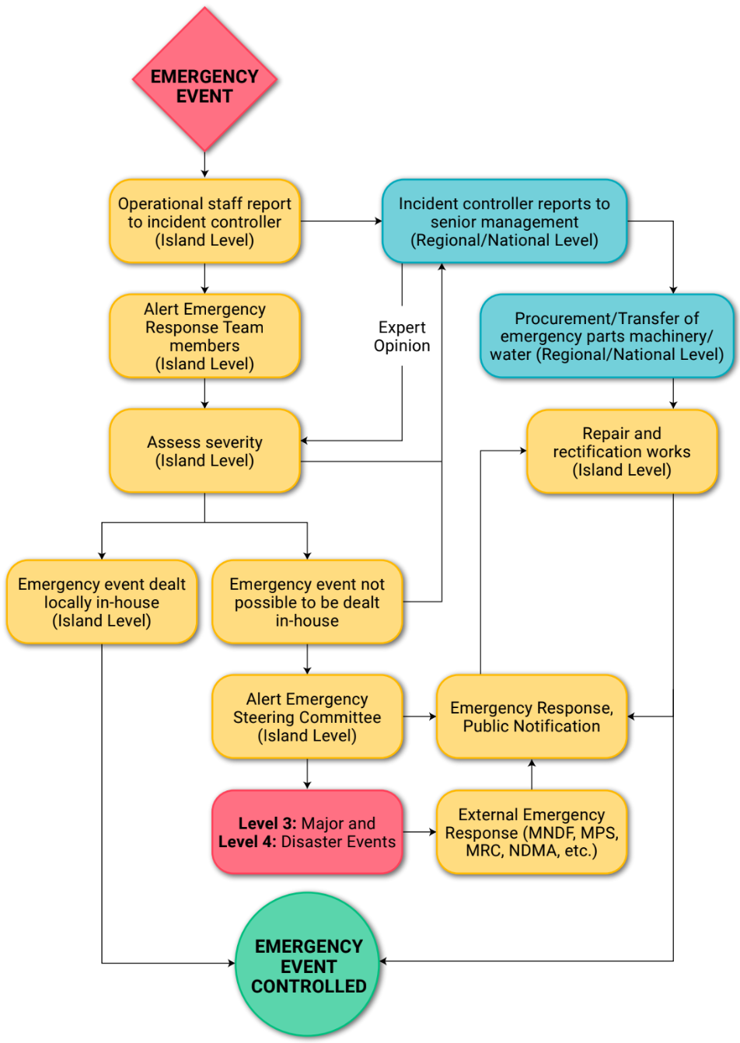
Figure 3: Crisis Communication Plan

Public Notification
(Attach emergency messages that have been prepared to be disseminated during an emergency. These messages shall provide clear and concise description of the emergency that has occurred, specific instruction and guidance, and contact information of the emergency services. Following is a sample of water advisory to be used in case of an emergency. (CDC, 2022) These notifications must be provided in multiple languages.
BOIL WATER ADVISORY FOR (WATER SYSTEM LOCATION)
[Date]

FOR IMMEDIATE RELEASE

Contact: [Name, Title, Phone, E-mail]

[Utility] issues a boil water advisory for all customers in [location]

[Utility] advises all customers to boil their drinking water. The boil water advisory is in effect until further notice.

Customers should:
- Fill a pot with water.
- Heat the water until bubbles come quickly from the bottom of the pot to the top.
- Keep heating the water for one more minute.
- Turn off the heat source and let the water cool.
- Pour water into a clean, sanitized container with a cover for storage.

Use bottled water or boiled water that has cooled for:
- Drinking
- Brushing teeth
- Washing fruits and vegetables
- Preparing food and baby formula
- Making ice
- Giving to pets

The advisory is in effect until [Water System] and [other agencies] are confident there is no longer a public health concern. We will provide the next update at [date or timeframe]. Customers will be notified immediately when the advisory is lifted.

Tests results from [date] showed [contaminant] at [levels/amount]. The [Primacy Agency/Health Department] is working closely with [Utility] to find the contamination source and fix the problem.
To correct the problem, we are [what is being done (e.g., chlorine was applied to the entire system)].

[Give dates or time estimate for duration of the advisory, if possible]. [Number or No] illnesses related to the community’s drinking water are reported.
If you are concerned about your health or your family, call your healthcare provider or the [local health department]. People at increased risk should seek advice about drinking water from their healthcare provider.]
Please share this information with all the other people who drink this water, especially those who may not have received this notice directly (for example, people in apartments, , schools, and businesses).

For more information, residents should call the (Utility) office at _____________, or the (other responsible agencies) ___________.

Prepare similar templates for the scenarios including but not limited to:
- DO NOT USE WATER Advisory after contamination events
- Loss of pressure or disruptions due to water shortages
- Sewer overflow warnings
- Water/Sewerage system infrastructure failure warnings.
- Natural disaster warnings

Business Continuity Plan
(Attach the BCP of the utility.)

Stage 5: Recovery
(This section outlines key recovery procedures and highlights the importance of post-emergency reporting and evaluation for continuous improvement.)

Recovery Procedures
(Provide the key recovery procedures that will be followed to restore and resume operations after interruptions to water/sewerage services. These procedures are to be explained in detail in the EOPs specific for each emergency type in Section 8.2.)

Post-Emergency Reporting
(Explain the use of the Incident Report to document the emergency response and recovery efforts.)
Table 25: Incident Report
Incident Details | Date of Incident: [Date]
Incident Details | Time of Incident: [Time]
Incident Details | Location: [Specific location of incident]
Incident Details | Type of Incident: [e.g., water main break, sewage overflow, power outage]
Incident Details | Incident Number: [Unique identifier]
Involved Parties | Reporting Personnel: [Name and position]
Involved Parties | Responding Personnel: [Names and positions]
Involved Parties | External Agencies Involved: [e.g., police, fire department, health department]
Incident Description | Detailed description of the incident: [A clear and concise account of what happened.]
Incident Description | Affected areas: [Specify the geographic area impacted by the incident.]
Incident Description | Number of people affected: [Estimate the number of individuals affected.]
Incident Description | Environmental impact: [Assess potential environmental damage.]
Response Actions | Initial response: [Describe the immediate actions taken upon incident detection.]
Response Actions | Emergency procedures activated: [Specify which emergency procedures were implemented.]
Response Actions | Resources deployed: [List equipment, personnel, and other resources utilized.]
Response Actions | Coordination with external agencies: [Outline communication and collaboration with external parties.]
Impact Assessment | Infrastructure damage: [Assess damage to water or sewerage infrastructure.]
Impact Assessment | Service disruptions: [Describe the extent and duration of service interruptions.]
Impact Assessment | Public health impact: [Evaluate potential health risks to the public.]
Impact Assessment | Economic impact: [Estimate financial losses due to the incident.]
Lessons Learned | Identify areas for improvement: [Highlight weaknesses in response procedures.]
Lessons Learned | Recommended corrective actions: [Suggest changes to prevent similar incidents.]
Attachments | [Photographs, diagrams, or other relevant documentation.]

Response Evaluation
(Explain the procedures for evaluating the effectiveness of the Water and Sewerage Emergency Plan and its implementation during emergencies.)

